USER ROLES

classes of user
- technical developer => Administrator
- SCYCOM moderator/admin => new roles “SCYCOM administrator" & “SCYCOM moderator"
- SCY team member => new role “SCY team member"
- co-developing teacher => role “co developing teacher"
- subscribed teacher => new user group “subscribed teacher group ”
- everyone => all registered liferay user

special classes
- Project leader

Details of Liferay user classes

- admin
- can create projects, organizations, users and roles
- can manage the page layout, e.g. place portlets, create links
- can set permissions for users, roles, every content portlet (e.g. special permission for blogs)
- has this role portal wide over different projects
- special role moderator and admin
- edit all content
- approve content
- edit user pages
- create projects
- scy team member
- visit team member places
- upload / download content
- co.developing teacher
- most equal with role 3., some less permissions (details at PROPOSAL FOR FUNCTIONAL)
- subscribed teacher
- user who subscribed to projects
- GUEST/SCYCOM project is main project of liferay
- user who subscribed to project has community members rights for this place
- everyone
- all registered users
- see more stuff at main site then no registered users
- Project Leader
- can create/delete/edit projects
- assign members to projects

How to give user role:
- My account
- Users
- Action/Edit
- Roles
- Select (chose role)
- Save Button

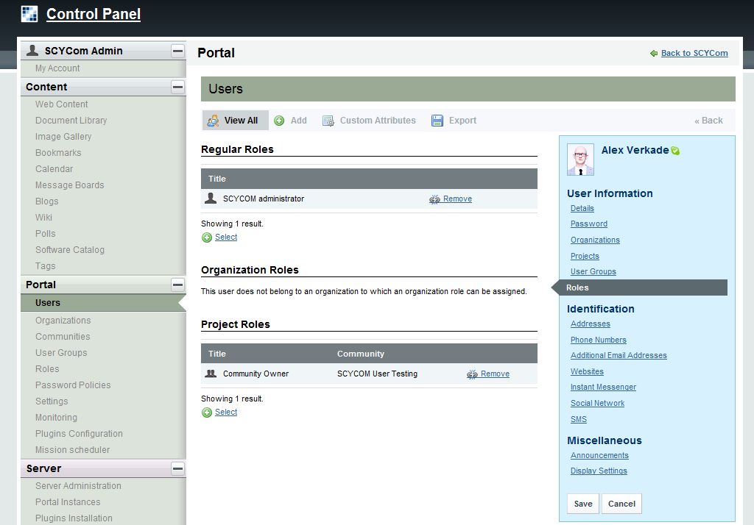
2.
4.
5.
6.

